BASH SCRIPTING ASSIGNMENT
Create a bash script to check if a directory is available or not.
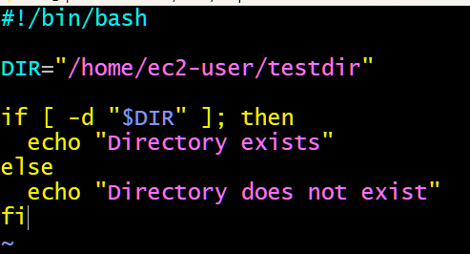
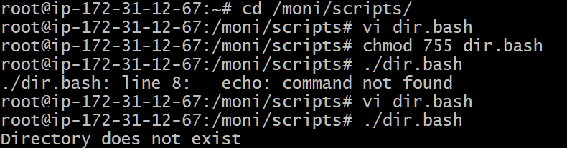
Create a bash script to create multiple files.
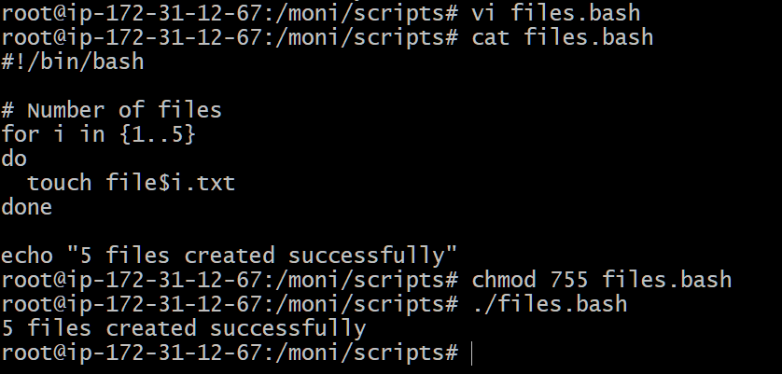
Create a bash script to take a backup of a directory.
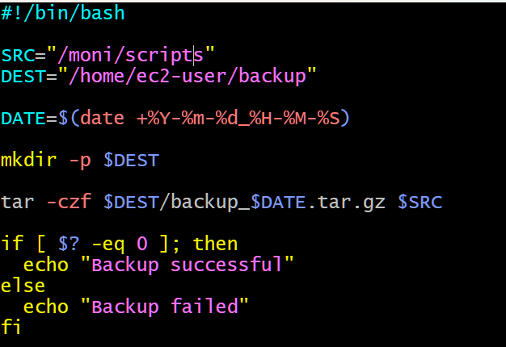
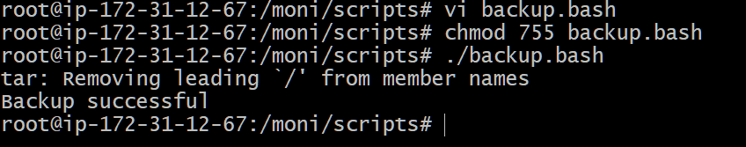
Create a bash script to install Nginx on an EC2 server.
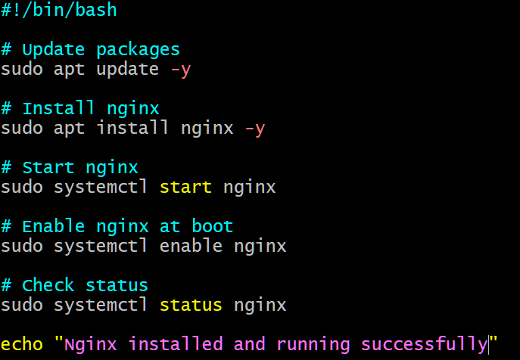
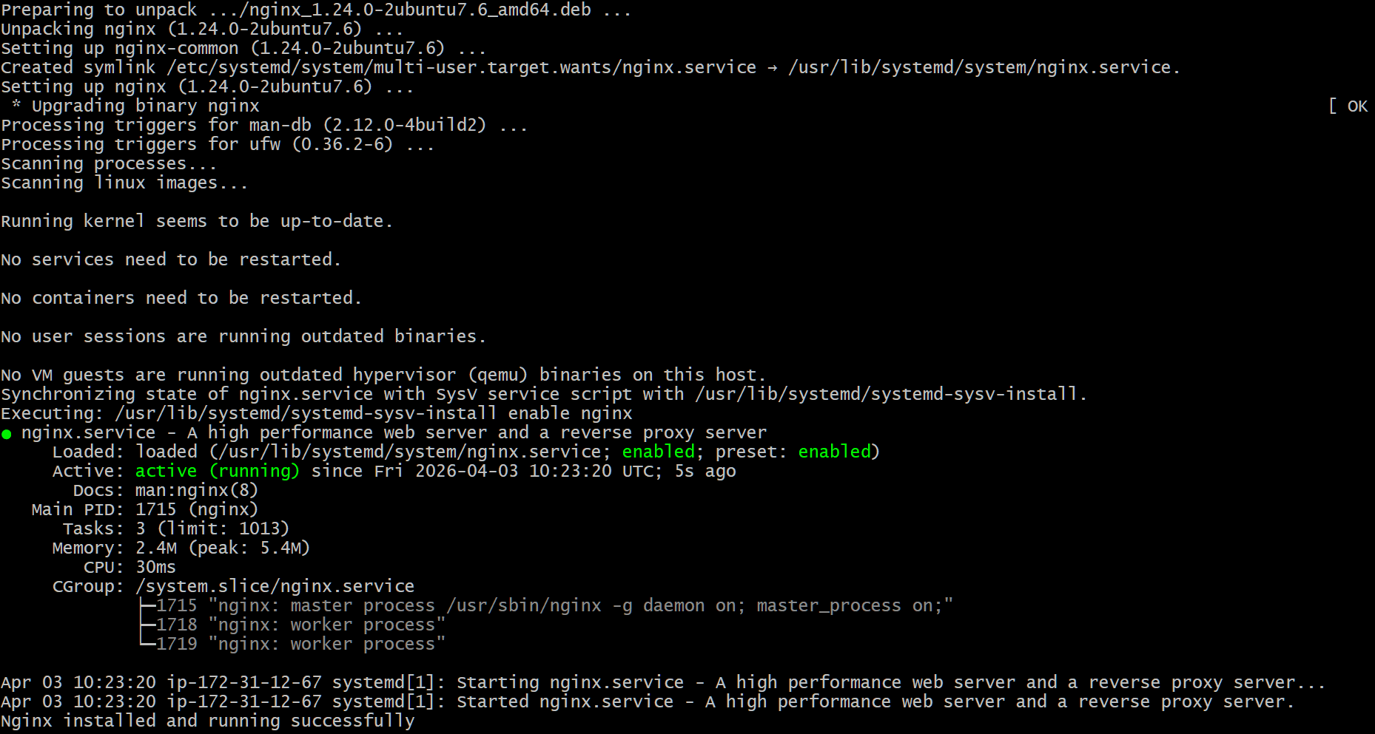
Create a bash script to install Apache Tomcat on an EC2 server.
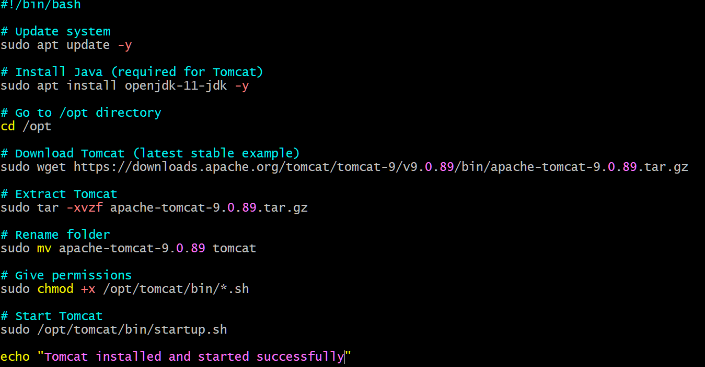
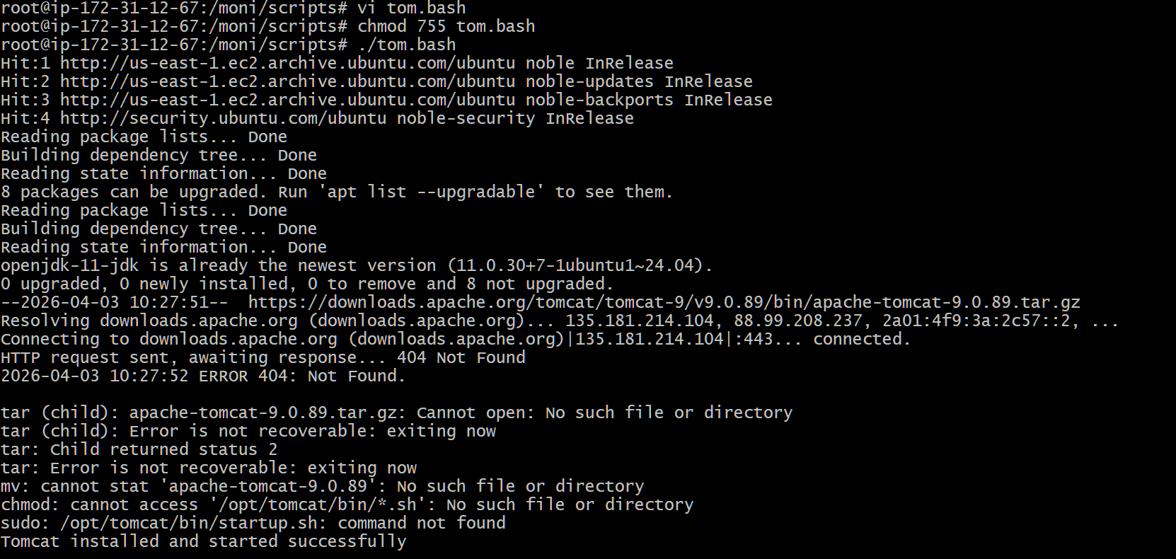
Create a bash script to check if the Nginx service is running, if not running then script should start the service.
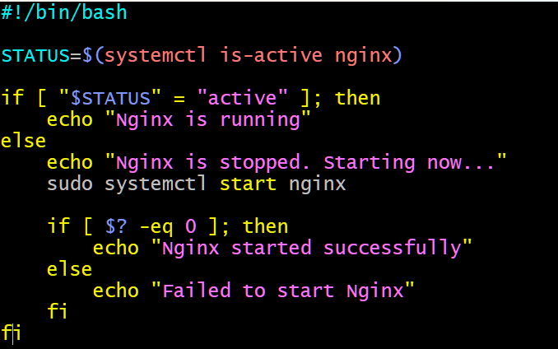
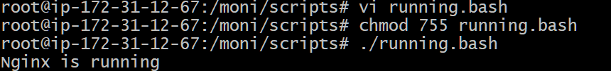
Create a bash script for a calculator.
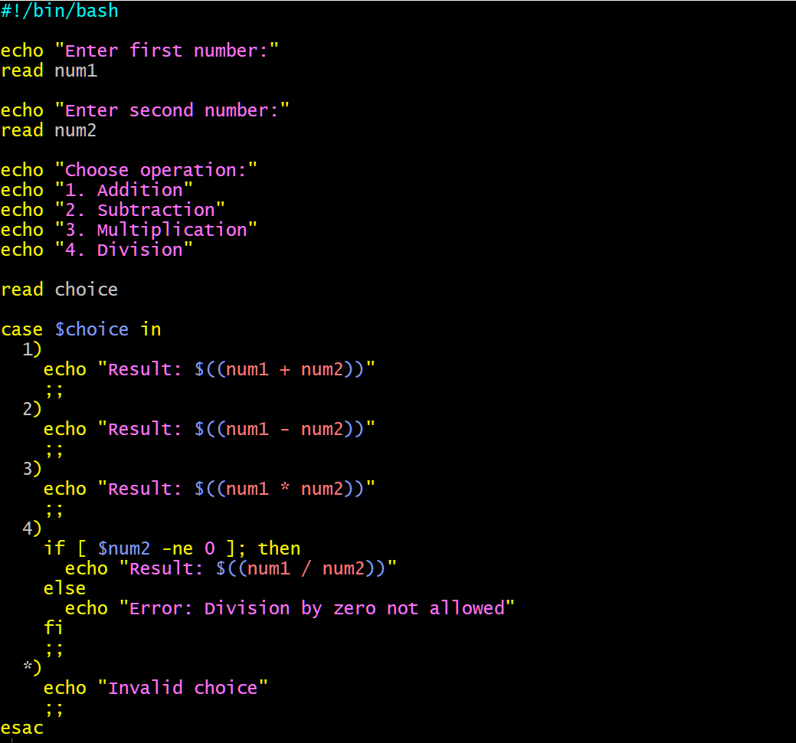
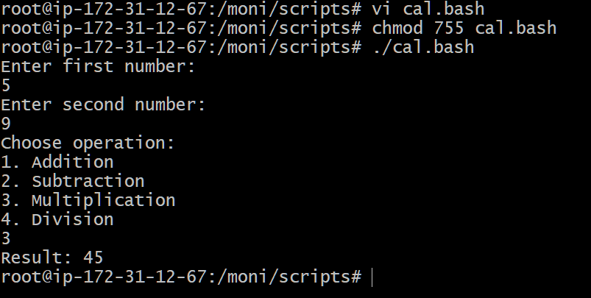
Create a bash script to check if a directory exists, if not then create a directory.
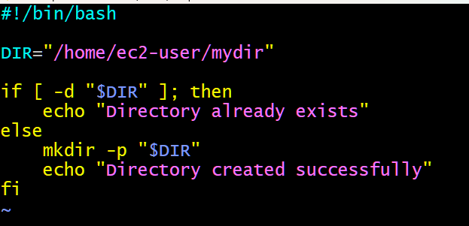
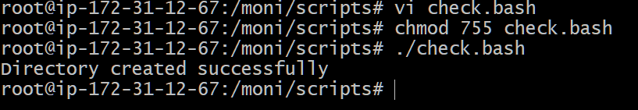
Create a bash script to delete the last 3 lines of a file.
